**SPools: Party Play Roles**

Overview

This document is created to map out the basic flow for the roles of Official (owner) and Player (user). Currently this document does not outline any login flow to create a unique id of the individual. This will be addressed later. Additionally, localization/filtering will also be addressed in a later step.

Game Phase I – Creation

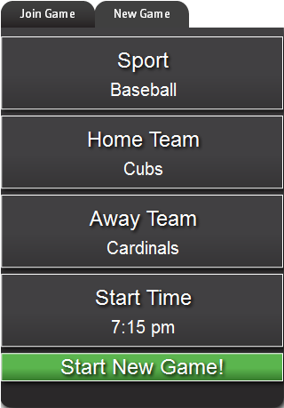Role: Official

1. Connects via URL
2. Screen shows a tab title NewGame (Fig. 1)
3. Select a sport

Figure

* 1. Baseball
  2. Football

1. *Enter name of Away Team (text field)
2. *Enter name of Home Team (text field)
3. Press Create Game button
   1. Call to database
      1. create game information
      2. allot tokens to game

*Reverse the Home and Away team order as in the game listings typically the Home team is shown second.

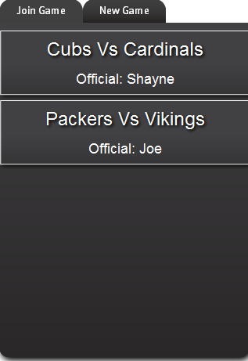Game Phase II – Join Game

Role: Player

1. Connects via URL
2. Screen shows a tab titled Join Game (Fig. 2)
3. Selects game (show a little baseball/football icon)
   1. Call to database
      1. Pull tokens
      2. Pull owners moniker for tokens

Figure

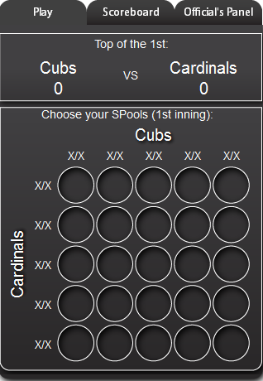Game Phase III – Token Selection

Figure

Role: Player

1. Screen shows tab titled Play (Fig. 3)
2. Click on token image
   1. Call to database
      1. Place request for token
      2. If token already taken message returned
      3. If token available moniker is added to screen

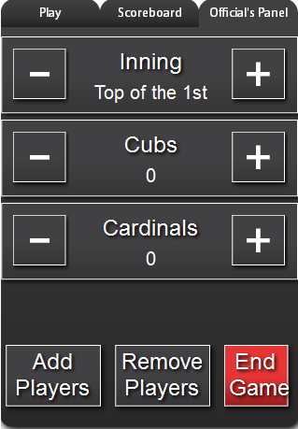Game Phase IV – Manage Game

Role: Official

1. Selects game like Player
2. Official tab shows only for the owner (Fig. 4)

Figure

1. Bottom buttons show
   1. Start Game
   2. End Game
2. Clicks start game
   1. Call to database
      1. Rows/Columns randomized
      2. Tokens locked from further selection
3. Score is adjusted with -/+ buttons
4. Game status (innings/quarter)

Game Phase V – End Game

Role: Official

1. Selects game like Player
2. Official tab shows only for the owner (Fig. 4)
3. Clicks end game
   1. Call to database
      1. Identify winners
      2. Notify winners